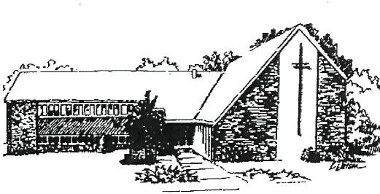
IMMANUEL LUTHERAN CHURCH
747 Ann Street – Chadron, NE 69337
Telephone: (308) 432-5408
Email: chadimmanuel@bbc.net
Pastor Ann Sundberg
Cell: (919) 475-9754

Where God is with us as we grow in faith!

GRACEVINE
October 2016
Pastor’s Message

Between September 16 and September 24 I drove over 1,700 miles to attend meetings all over Nebraska. A trip to Alliance along with Robyn Baquet, Karen Rupp and Laurie Schmidt to attend a training on transformational ministry. A trip to Omaha for the Cluster Deans meeting (I serve as the Dean of the Panhandle Cluster of our Synod.) A trip to Scottsbluff for the meeting of our Panhandle Cluster. And finally, a trip to North Platte to attend a gathering of spiritual directors.
In addition, we were visited on September 21 by Lisa Kramme, Director of Faith Formation for the Nebraska Synod. She visited Wednesday School and Confirmation classes and had an opportunity to talk with parents and teachers over supper.
So much is going on in our congregation. Baptisms, classes, meals, prayers, hikes, new friendships, conversations, invitations, worship and care for each other.
And we have so many connections – to the churches that are our neighbors here in western Nebraska, and to all the churches that comprise the Nebraska Synod. So many ministries that we are part of – from campus ministry to our Wednesday School, from the Shepherd’s Pantry to Seeking the Spirit Within, which trained and formed me for the ministry of spiritual direction.
This coming year will be the 500th anniversary of Martin Luther nailing his 95 theses to the door of the Wittenberg Church and starting the movement that we know as the Reformation. The connections we have extend outward to churches all over the world through the Lutheran World Federation. We are even holding discussions with our Roman Catholic brothers and sisters about how we might find our way together to sharing Holy Communion and ministry.
We gather as the church of Jesus Christ for the sake of the world. We gather to be transformed by God’s Word, nourished by the sacraments, and sent to live out God’s mission in our community and the world.
You are invited to participate in a congregational retreat at Camp Norwesca on Saturday, October 15 from 8 am – 3 pm. Using the book of Acts as our guide, we will reflect on what God’s mission is for our congregation and how we are being called to carry out that mission. We will reflect on our own stories of faith. We will look for God’s activity in our congregation and in the community that surrounds us. Please plan to attend.
Perhaps you’ve heard me say this before: You can’t be a Christian by yourself. We are part of God’s plan, the unfolding of hope for the entire world.

Council Meeting Minutes September 2016
Council for Immanuel Lutheran Church met on September 1 with the following persons in attendance. Pastor Ann Sundberg, Robyn Baquet, Sharon Thurlow, Barb Landen ,Chelsea Holt, Karen Rupp, Karleen Gramberg and Laurie Schmidt. Absent were Denise James, Tru Thorn, Yvonne Moody, and Julie Duncan.

Devotions consisted of talking about Chapter 8 the book that council is reading and Acts 10.
There were no minutes for the August meeting.
Treasurers Report was approved as presented with a motion from Karleen and a second by Karen.

New business included setting up chairs for the funeral of Jerry Johnson. Clean up after the service for Wednesday School. September 11 is God's Work Our Hands. A secretary has been hired. . Serv
Pastor's Report Met with families of perspective confirmation .Taught adult Christian education. Served lunch at Closer to Home. Attended Panhandle cluster retreat.
Grounds: Scheduling an outdoor workday is to be scheduled. Tentative date is October 2. A list will be prepared of the chores that need to be done

Education: orientation for parents for Wednesday School. Teacher are expected to be Lisa Briggs, Chelsea Holt, Stacy Larson, Trista Schell and Troy. Bev will be teaching the confirmation kids as will Pastor.

Evangelism: Pastor met with Courtney. Set up the Campus Ministry schedule.

Fellowship Move in day at Chadron State. Tentative date for Fall Feast is November 13th.

Social Ministry: Shepard's Pantry served 39 adults and 25 children in August. THe church will serve Closer to
Home on September 19th and October 17th.

Worship: We are switching to setting three. No more flipping between hymnals.

Stewardship: Book group met 2 times to discuss "Enough". Stephanie Cogdill gave a temple talk and Karen Rupp gave one also.
Looking to have a noisy during church service for the children.

Council/Congregation Retreat at Camp Norwesca, Saturday, October 15
Pastor Ann, Laurie Schmidt, Karen Rupp and I attended the Transformational Ministry Training held in Alliance on Friday, Sept 16th and Saturday, Sept 17th. Wow! Talk about perfect timing! Our council has been studying the Book of Acts and exploring what God’s Mission is for our church. And this training reinforced that we are on the right track and clarified our next steps.

We are thrilled that Rev. Steve Meysing,, Assistant to the Bishop, has agreed to facilitate exploring the topic of “What is God’s Mission for Our Church” with us. We all have questions about our purpose in life, and our collective purpose of our congregation. Understanding what God’s Mission is, helps us define who we are and what we want to be. And knowing our purpose and mission will guide us in making decisions about how we go about doing God’s work. God’s Work, Our Hands!

Please join us for a congregational retreat on Saturday, October 15th from 8:30 am to 3:00 pm at Camp Norwesca. Come hear Steve Messing lead us in exploring God’s Mission for Our Church. It will be transformational! – Robyn Baquet *(See page 4 to indicate your attendance)*
Stewardship
Dear Brothers and Sisters in Christ,
Summer comes to an end and we move into fall, a season of dramatic transformation as leaves change color and fall from their branches, temperatures drop and hours of daylight decrease. This is often a time we reap the harvest of the labors of spring and summer and prepare for winter.

It is also a time we examine where we are and look to determine where we want to be. We’ll be sending out letters asking you to consider opportunities to share in the ministries of our congregation. To set the tone and prepare our hearts and minds to prayerfully consider what we can do as individuals, as family units and as a congregation, I share in part our presiding Bishop Eaton’s message in Stories of Faith In Action.’

“It was an inconsequential gift – two small coins – yet to the widow, it was everything. Observing the faithful widow and the rich as they shared their offerings, Jesus said to his disciples, ‘Truly I tell you, this poor woman has put in more than all those who are contributing to the treasury. For all of them has contributed out their abundance, but she out of her poverty has put in e everything she had, all she had to live on.’ (Mark 12:43-44)

What a remarkable story. Every time I read this passage I’m astonished by the widow’s generosity. And every Sunday when we worship as a faith community and offering plates are passed in ELCA congregations across the country, I am inspired by members who give lavishly and lovingly to do God’s work. Thank you for your faithfulness!

Their offering and your offering matter. Combined with gifts from other ELCA members your offering strengthens and extends the ministry of your congregation, your synod, and the wider ministry of this church…

Jesus calls us to steward our time, talents and treasures to share the good news with a world that is longing to hear it. He cared and still cares about what we give.”

You many have noticed in our monthly Gracevine financial report a negative monthly bottom line. Our giving, as generous as it is, is not matching outgo…so to have a “balanced” budget” we need to increase giving, do some additional fundraising, or decrease expenses. Please consider and offer your suggestions as to how we can reverse the shortfall trend. Looking ahead to a new year, think about how we can live into our mission, as that is what our budget reflects – our mission .

Again, thank you for all you do. Please consider volunteering to join the Stewardship Committee – just speak to Karen Rupp, Jeanine Mohr or Pastor Ann,

Peace and Blessings, Karen Rupp, Stewardship Chair

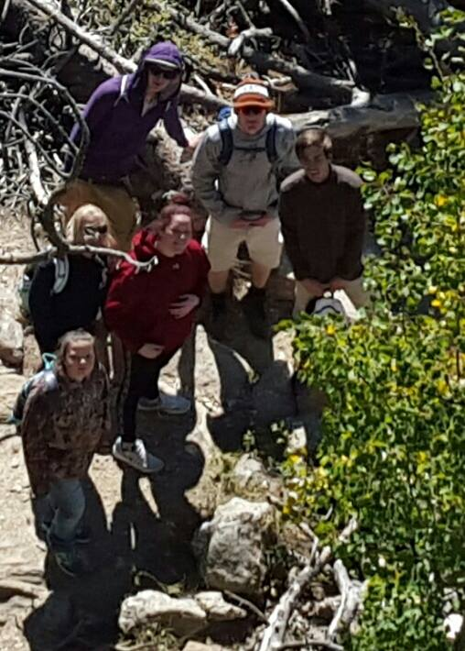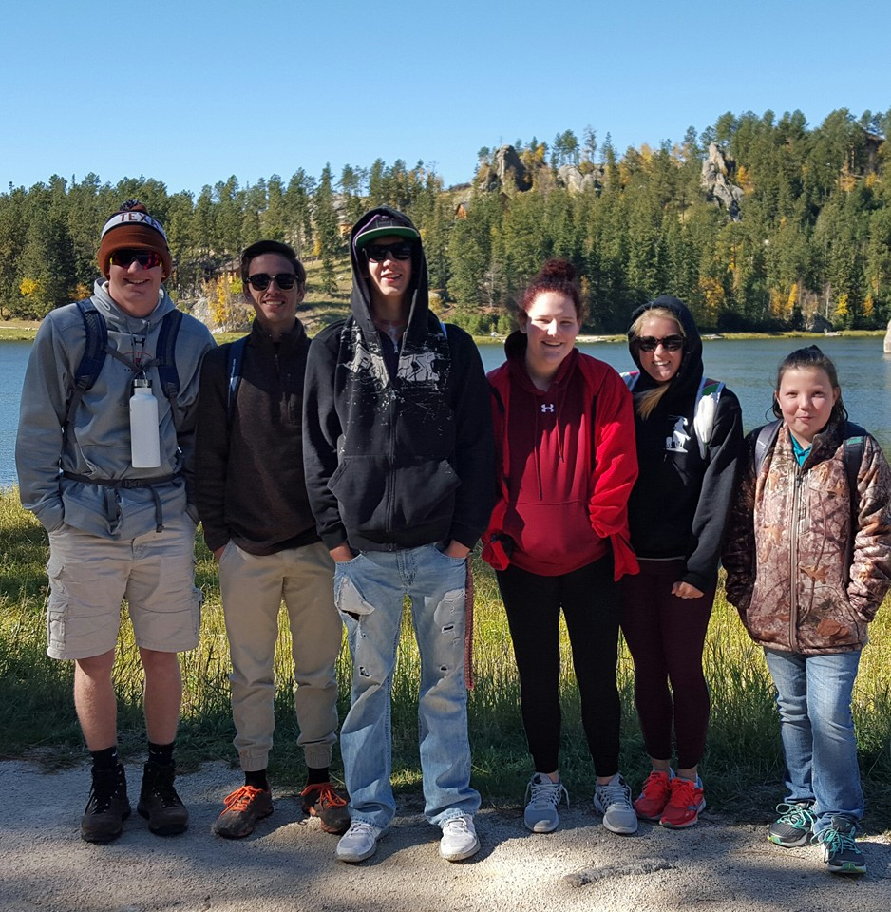
A few of Immanuel’s youth went hiking up Black Elk aka Harney Peak on September 25. Good fellowship in God’s creation. From L-R: Keegan Shuck, Chace Franey, Jarrod Briggs, Katelyn Briggs, Maddy Nygren and Leah Weber.

Council/Congregation Retreat at Camp Norwesca, Saturday, October 15

Over the course of the past few months, the Congregation Council has been reading through a book called Renewing Your Congregation by Rev. Dave Daubert, a Lutheran pastor in Elgin, IL. There are sheets of butcher paper hanging in the fellowship hall with some of the topics we have discussed:

- What is God’s dream for our congregation? What things have happened over the course of our congregation’s history that have contributed to God’s dream?

- What is God doing in this community? How can we be a part of that work?

- If God has God’s way with our congregation for five years, what do you see in our future?

- Complete this sentence in 12 words or less: “God’s purpose for our congregation is…

- - - - - - - - - - - - - - - - - - - - - - - - - - - - - - - - - - - - - - - - - - - - - - - - - - - - - - - - - - - - - - - - - - - - - - - - - - - - - - - - - - - - - - - -

_____ Yes, I/We plan to attend the Council/ Congregation Retreat.

Name(s): _____________ Any Dietary restrictions:_________________________
___________________________________________ _____________________________________________
___________________________________________ _____________________________________________

Treasurer’s Report
September 2016 (Incomplete)

Beginning balance August 31, 2016 $ (5,921.76)

Income Weekly Offering $ 6,772.69
Thrivent $ 536.00

Total Income $ 7,308.69

Expenses $ 9,672.09

Ending balance as of September 29, 2016 $ (8,285.16)

Worship Attendance

Date | Sunday Service
September 4 | 66
September 11 | 63
September 18 | 46
September 25 | 62

Baby Shower for Tyleigh Mae
Come congratulate Haleigh and help welcome her sweet angel!
Sunday October 9th, 2016 2:00-4:00 pm
Immanuel Lutheran Church 747 Ann Street, Chadron
Registered at Wal-Mart and Target

Feeding the Community
We are scheduled to serve at Closer to Home on Monday, October 17. Sign-up sheets will be posted on the kitchen door. We served 27 meals in September. Thanks to all who have volunteered to serve and who have provided food. When we feed our hungry neighbors, we serve Jesus Christ himself.

The next Campus Ministry supper will be Sunday, October 9. Thank you to Denise James and Lucinda Mays for providing supper.

Fall Feast Coming Up
Fall is upon us! Now it is time to plan our annual Fall Feast, to be held on November 13. This is a big event for our church as we offer a wonderful "pre-Thanksgiving meal open to all. In order to do this we need help from everyone! Please check the kitchen door to sign up. Help of all kinds is needed and I thank you in advance for your willingness and generosity. -Karleen Gramberg, Hospitality Chair

Kit Watson/ Whitney Tewahade Art Exhibit

What:*Exhibit-October 6-30, 2016
*Reception- Thursday October6th 5-7 p.m. FREE and open to everyone!
Where: West Nebraska Arts Center 106 East 18th St. Scottsbluff, NE 89361
When: Gallery hours- Tues.-fri, 9 am - 5pm … Sat. & Sun. 1 - 5pm

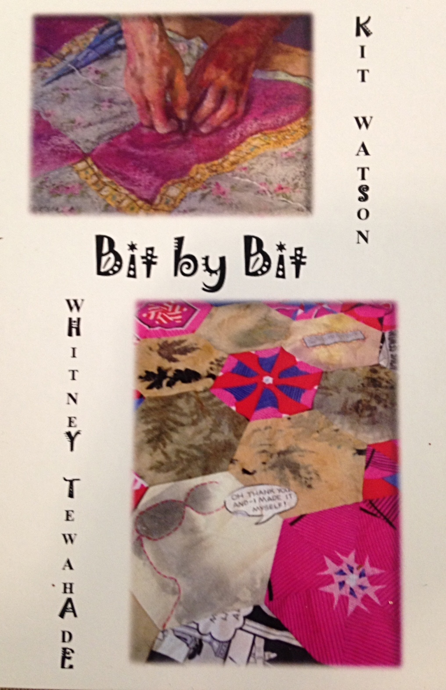
Other Staff –
Financial Secretary – Lorrie Bauer
Custodian – Michelle Haynes
Church Secretary – Mckailie Carnahan-Kuhns

Important contact information-
Nebraska Synod Website:
www.nebraskasynod.org, phone number
402-896-5311
ELCA Church wide Website, www.elca.org,
Phone number 800-638-3522
COUNCIL MEMBERS

President - Robyn Baquet
Vice-President - Denise James
Secretary - Sharon Thurlow
Treasurer – Chelsea Holt
Building & Grounds -
Education - Yvonne Moody
Evangelism - Laurie Schmidt
Fellowship - Karleen Gramberg
Social Ministry - Barb Landen
Stewardship - Karen Rupp
Worship - Julie Duncan
Youth/Young Adult - True Thorne
Pastor - Ann Sundberg

Other Staff -
Financial Secretary - Lorrie Bauer
Custodian - Michelle Haynes
Church Secretary - Whitney Tewahade

Important contact information:
Nebraska Synod Website: www.nebraskasynod.org, phone number
402-896-5311
ELCA Church wide Website: www.elca.org, phone number 800-638-3522

Immanuel Lutheran Church
747 Ann Street
Chadron, NE 69337

